Lab 15: Exception Handling
Covering Lectures: Lectures 43
Objective:
This Lab aims to give students a complete understanding of Error Handling techniques.
Learning Outcomes:
After completing this lab students will be able to practice different error-handling techniques:
- Abnormal Termination
- Graceful termination
- Return the illegal value
- Return error code from function
- Exception handling.
Problem Statement:
Write a C++ program to create a method that takes a string as input that must have vowels in it. For example, “Hello” is a valid input as it has two vowels ‘e’ and ‘o’ while “XYZ” is not a valid input as the string has no vowels.
Suppose a user enters a string with no vowel so arises an error. Apply the given Error handling techniques to handle this error in your program.
- Graceful termination
- Exception handling.

Sample Output:
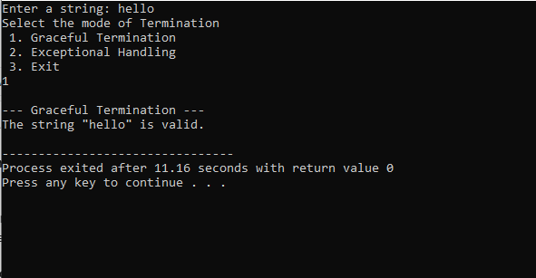
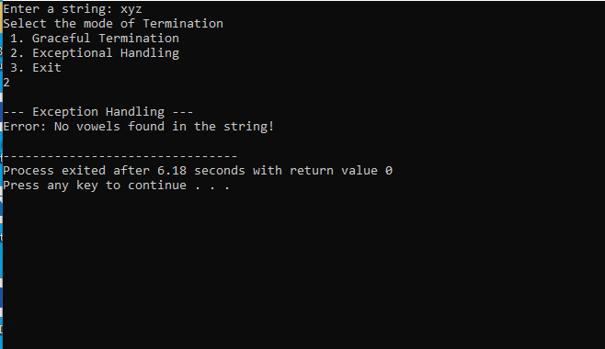

Practice Questions:
Write C++ programs for the above scenario using the given Error-Handling techniques.
- Abnormal Termination
- Return the illegal value
- Return error code from function

